**Comsats University Islamabad, Abbottabad Campus**



**Medicine Stock**

# CHAPTER 1 & CHAPTER 2

**Group Leader: Abdul Qadir**

|  |  |
| --- | --- |
| Name | Register No |
| Abdul Qadir | **SP21-BSE-098** |
| Muhammad Arif | **SP21-BSE-090** |
| Basheer Ahmad | **SP21-BSE-093** |

**Subject: OOSE**

**Submitted to: Mukhtiar Zamin**

**Date: 25/09/2022**

Contents

CHAPTER 1 PROJECT PROPOSAL 1

**Introduction:** 3

**Vision and Business Case:** 3

Use-Case Model: 4

4

**Supplementary Specification:** 5

**Glossary:** 5

**Risk List & Risk Management Plan:** 5

**Malware** 5

**Theft & Loss** 5

**Unsafe data** 6

**Negligence** 6

**Brief level use case: (Abdul Qadir)** 6

**Fully dressed use case: (Abdul Qadir)** 8

**Brief level use case: (Muhammad Arif)** 13

**Fully dressed use case: (Muhammad Arif)** 14

**The brief level case:** **(Basheer Ahmad)** 17

**The full Address:**  **(Basheer Ahmad)** 18

|  |  |  |  |
| --- | --- | --- | --- |
| Name | Brief Level UC | Fully Dressed | Prototype show |
| Abdul Qadir | Available P# (7) | Available P# (9) | Available P# (14) |
| Muhammad Arif | Available P# (15) | Available P# 16() | Available P# (19) |
| Basheer Ahmad | Available P# (20) | Available P# (21) | Available P# (25) |

**Table Sow to access activities of each member easily**

## **Introduction:**

The Medicine Shelf is a free web application under OOSE program.

This provides the most of easiness in the arrangement and deals with the medicine; it also provides the online features for the patients and general suppliers of medicine from different cities and provinces. It also has the facility of providing the services physically. These days in the market, demands for the modern app is in top. Every aspect of life we need to have a complete grip on the management of medicine. This app will have simple use for the admin to search the medicine for the customer through the software. The software will search all the added medicines if available in the stock.

If the medicine is not available, the user will simply add the product to the software in order to be present in the stock. Besides, we have deal with the great medicine supply companies.

This app is generally use in the pharmaceutical centers. The app provides to have record of all the customers to which the medicine is sale and the debts.

## **Vision and Business Case:**

Our vision for creating this website is to provide better and safe services for the users the one who need the medicine in a remote area that do not have any source for receiving them and as well according to the money transfer this application will provide best options to receive and send their transactions easily without wasting their time.

So this medical shelf will pave the way for their orders and needs that they have with their clinics pharmacies or etc.

And as well this application will help with the pharmacists to have the maintenance and record of their available items and messing items and the items which they need for.

In business side we see Nava days that pharmacy and medicine has a crowded bazar that lots of our businessmen want to invest in this field so by this application they will do their work easily on their finger tips

## Use-Case Model:

## 

## **Supplementary Specification:**

These are some Non Functional Requirements as we together in this inception phase. Security requirements are important factors in this system as classified data will be stored in the database. customer validation will be done during login to insure that the user is valid and that the customer only has access to his or her permission data. General users will only have access through the user interface. The system will have consistent interface formats and button sets for all forms in the application, will have a form based interface for all data entry and viewing formats. The system will be easily maintained by authorized trained person and it shall respond as fast as possible in generating report and producing the timetable.

## **Glossary:**

The Medicine Stock web application is a dynamic mechanism; it has quiet easy friendlier features with a simple dashboard and main features. All necessary terms are excluded and progressed with simple understandable terms and general UI.

## **Risk List & Risk Management Plan:**

* The medicine shelf is to be develop under a specified IDE, so the IDE is not obvious which one is more preferred.
* An advanced programming language is involving for its backend development, for now we have java, so the concept of advance JAVA is not clear to us.
* A desired database is another risk under which the software has to be developed. For now, we are the fresher for the data storing and managing.

## **Malware**

Digital hackers watching your every move and trick you to download malware and take control of your computer remotely. They use malware to attack computer networks to perpetrate crimes. Fraudsters use virus, malware, spyware, spams, and phishing to gain access to your sensitive personal information and commit financial crimes. Defend your data against malware through secure servers, whether physical or in cloud, and shield against vulnerabilities.

## **Theft & Loss**

Unauthorized users without permissions who have access to sensitive data can cause harm to educational institutions because of theft. There is a risk of the sensitive academic data will be leaked by staff. It becomes easy to lose your storage media with backup data due to misplacement or theft. When you suffer data loss due to various incidents such as mechanical damage, power failure, software crash, disasters or loss of your laptops and mobile devices, it is another way of inadvertent data exposure. Keep all your data safe and secure using role-based access control to ensure confidentiality and privacy.

## **Unsafe data**

If adequate safety precautions are not taken when files and documents are shared in website. smartphones and tablets via internet networks, the information contained on them might gain access to the devices and are exposed to risks. We can make use of cloud deployments to manage the education system better and better.

## **Negligence**

When data is stored in computers or laptops, it has become so natural that people lose the information when files are accidentally deleted or even it could fall into the wrong hands. Ensure a proper backup strategy to keep your data on important devices and run them smoothly without hassles.

* Server related
* Frontend related

**Chapter 2**

# **Brief level use case: (Abdul Qadir)**

**Abdul Qadir (sp21-bse-098)**

**Use case: login**

In the use case a request is sent to the system called as toLoginRequst, the admin will be provided with username and password, this will allow the admin to have permission for further activity as mention bellow in other use cases.

**Use case: addEmployee:**

Before the employee is login to the system he has signed up, now he is the one who serve the patient or customer when the order of medicine is received, he can add the medicine if missing otherwise submitting it. I have the authority to add the employee before he starts the activity. I require the fullname, fulladdress, contact and email address.

**Use case: removeEmployee:**

As the employee is provided with these all information, I as the admin has the complete ownership to remove the employee in case when we do not agree on contract or in another case. There can be lots of employee in different cities.

**Use case: add Worker:**

Before the worker is login to the system he has signed up, now he is the one who serve the patient or customer when the order of medicine is received physically, he can search the medicine in the stock to deliver. I have the authority to add the worker before he starts the activity. I require the fullname, fulladdress, contact and email address so when any information is needed further this will help.

**Use case: removeworker:**

As the worker is provided with these all information, I as the admin has the complete ownership to remove the worker in case when we do not agree or in another case. There can be many workers in stock in different cities.

**Use case: seeingMedicineInformation:**

This describes the information about the medicine such as name, company name and the price also how much been sold yet.

**Use case: addMedicineContract:**

I import the medicine or locally buy the medicine and give message to employee to add further. This contract is with different local and global companies.

**Use case: editMedicine:**

If any information is needed to add to the medicine, so I can edit if any nothing is done mistakenly.

**Use case: updateMedicine:**

Sometimes, the name is changed or the same medicine is produced by different companies so somethings can be updated.

**Use case: deleteMedicine:**

If this product is not produced anymore or the product is banned so that can be also delete in order not to have buying contracts.

**Use case: seeingOrders:**

In this a graph will be shown to me if we really improving or doing profit.

# **Fully dressed use case: (Abdul Qadir)**

**Abdul Qadir (sp21-bse-098)**

**UC1:**

**Scope:** (Stock, company)

**Primary actors:** (Admin)

**Stack holder and interests:**

**Stock:** the physical place where medicine is stored, to the stock the employee and workers have access.

**Company:** arranges everything officially having the contracts under the owner or main admin. With its own logo and trade registered.

**Patients or customers:** they are the ones from whom we get the orders.

**Suppliers:** from global and local companies the medicines are ordered.

**Employees and workers:** employees are those who serve the clients or you can say the customers. In addition, the workers are supposed to deliver the medicines.

**Preconditions:** each one who is involve has a specific id and information. Further, it is underway.

**Success guarantee:** providing medicine services online has lot of benefits, it creates interests and comfort zone.

**Main success scenario:**

* Admin: give access to all staff involved in the medical stock company
* Employee: works with medicine, adding and searching and editing or removing the medicine.
* Workers: they get orders from employees.
* Customers: they search the medicine online in our website than add to buy and further process for purchasing completing.

**Alternative flows:** if the service is not applicable in one branch or city due to the website down or other unexpected issues to the admin has to debug the errors through developers.

It the issue is technical admin has to wait until it is solved and resolved.

**Special requirements:** presenting with specific ID number, access to internet and providing own identity as admin.

**Technology and variants:** connection to system the dynamic mechanism.

**UC2:**

**Scope:** (Stock, company)

**Primary actors:** (Employee)

**Stack holder and interests:**

**Stock:** the physical place where medicine is stored, to the stock the employee and workers have access.

**Company:** arranges everything officially having the contracts under the owner or main admin. With its own logo and trade registered.

**Patients or customers:** they are the ones from whom we get the orders.

**Suppliers:** from global and local companies the medicines are ordered.

**Employees and workers:** employees are those who serve the clients or you can say the customers. In addition, the workers are supposed to deliver the medicines.

**Preconditions:** each one who is involve has a specific id and information. Further, it is underway.

**Success guarantee:** providing medicine services online has lot of benefits, it creates interests and comfort zone.

**Main success scenario:**

* Employee: works with medicine, adding and searching and editing or removing the medicine.
* Workers: they get orders from employees.
* Customers: they search the medicine online in our website than add to buy and further process for purchasing completing.

**Alternative flows:** if the service is not applicable in one branch or city due to the website down or other unexpected issues to the Employee has to debug the errors through developers. It the issue is technical Employee has to wait until it is solved and resolved.

**Special requirements:** presenting with specific ID number, access to internet and providing own identity as Employee.

**Technology and variants:** connection to system the dynamic mechanism.

**UC3:**

**Scope:** (Stock)

**Primary actors:** (Worker)

**Stack holder and interests:**

**Stock:** the physical place where medicine is stored, to the stock the employee and workers have access.

**Patients or customers:** they are the ones to whom we accomplish orders.

**Employees and workers:** employees are those who serve the clients or you can say the customers. In addition, the workers are supposed to deliver the medicines.

**Preconditions:** each one who is involve has a specific id and information. Further, it is underway.

**Success guarantee:** providing medicine services online has lot of benefits, it creates interests and comfort zone.

**Main success scenario:**

* Workers: they get orders from employees.
* Customers: they search the medicine online in our website than add to buy and further process for purchasing completing.

**Alternative flows:** if the service is not applicable in one branch or city due to the website down or other unexpected issues to the worker has to debug the errors through developers.It the issue is technical worker has to wait until it is solved and resolved.

**Special requirements:** presenting with specific ID number, access to internet and providing own identity as worker.

**Technology and variants:** connection to system the dynamic mechanism.

**UC4:**

**Scope:** (Stock, company)

**Primary actors:** (Employee, Admin)

**Stack holder and interests:**

**Stock:** the physical place where medicine is stored, to the stock the employee and workers have access.

**Company:** arranges everything officially having the contracts under the owner or main admin. With its own logo and trade registered.

**Patients or customers:** they are the ones from whom we get the orders.

**Suppliers:** from global and local companies the medicines are ordered.

**Employees and workers:** employees are those who serve the clients or you can say the customers. In addition, the workers are supposed to deliver the medicines.

**Preconditions:** each one who is involve has a specific id and information. Further, it is underway.

**Success guarantee:** providing medicine services online has lot of benefits, it creates interests and comfort zone.

**Main success scenario:**

* Employee: works with medicine, adding and searching and editing or removing the medicine.
* Workers: they get orders from employees.
* Customers: they search the medicine online in our website than add to buy and further process for purchasing completing.

**Alternative flows:** if the service is not applicable in one branch or city due to the website down or other unexpected issues to the Employee has to debug the errors through developers. It the issue is technical Employee has to wait until it is solved and resolved.

**Special requirements:** presenting with specific ID number, access to internet and providing own identity as Employee.

**Technology and variants:** connection to system the dynamic mechanism.

**UC5:**

**Scope:** (Stock, company)

**Primary actors:** (Worker, employee, admin)

**Stack holder and interests:**

**Stock:** the physical place where medicine is stored, to the stock the employee and workers have access.

**Patients or customers:** they are the ones to whom we accomplish orders.

**Employees and workers:** employees are those who serve the clients or you can say the customers. In addition, the workers are supposed to deliver the medicines.

**Preconditions:** each one who is involve has a specific id and information. Further, it is underway.

**Success guarantee:** providing medicine services online has lot of benefits, it creates interests and comfort zone.

**Main success scenario:**

* Workers: they get orders from employees.
* Customers: they search the medicine online in our website than add to buy and further process for purchasing completing.

**Alternative flows:** if the service is not applicable in one branch or city due to the website down or other unexpected issues to the worker has to debug the errors through developers.

It the issue is technical worker has to wait until it is solved and resolved.

**Special requirements:** presenting with specific ID number, access to internet and providing own identity as worker.

**Technology and variants:** connection to system the dynamic mechanism.

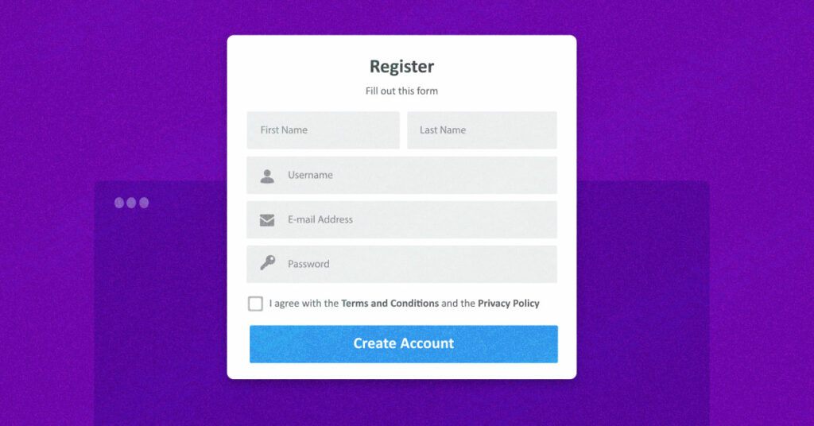

**The above proto type is about register so I have to register first myself and fill with all credentials required in the form.** (Abdul Qadir)

# **Brief level use case: (Muhammad Arif)**

**Muhammad Arif sp21-bse-090**

**Use case: Register**

Register use case is a use case the employee register itself and provide personal information like name, contact, email, full address, username and password.

**Use case: Login**

Login use case is used after employee register itself in the system and then login to the system. The employee only provides username or email and password.

**Use case: Add medicine**

In this use case, the employee adds the medicines information like name of the medicine, company name, and price and expiry date.

**Use case: Edit medicine**

Edit medicine is a use case that if the employee enters wrong data like name, price etc. then edit the name of medicine, price, and company name and expiry date.

**Use case: Delete Medicine**

Employee can delete the medicine, which is not available in the stock, or a company stop the production of the medicine.

**Use case: Seeing Orders**

Seeing orders use case that employee see all orders from the customer side. Employee notifies from the system. Employee can see the customer name, medicine name and quantity that order, contact, full address.

# 

# **Fully dressed use case: (Muhammad Arif)**

#### **UC1: Add Medicine**

Scope: Add medicine to the system

Primary Actors: Employee.

Stake holder and interest:

Employee: it is easy for employee to add medicine to the system and in the future easily to find it and medicine update directly in the system and there is less chance of errors. The system generates medicine list. The employee will have full record of stock the items that are short in stock and available items will clearly display.

Preconditions: Employee must be authorized through username and password.

Success guarantee (or Post conditions): the user and costumer will fully authorized and will help them to have fully relax with buying medicine and having online transaction.

Main success scenario or Basic flow:

* Employee add medicine, delete medicine to the system
* Employee save the records in the database.
* The system generates report for admin.
* Employee can view the medicine list in the system.

Extension or alternative flows:

At any time, username cannot be registered:

* During adding, deleting or updating the medicine, the username may not work every time.
* If the username and password cannot work employee should use their ID NO for the system.

If system does not recover:

* The user will suspend the operation and the system will show an error message.
* The user starts a new operation and continue to his work.

Special requirements:

* There should be a computer for the employee to add medicine to the database.
* The computer should be connected to system.

Technology and Data Variations List:

The computer should be connected to the system.

#### **UC2: Update medicine**

Scope: Update medicine in the database

Primary Actors: Employee.

Stake holder and interest:

Employee: Employee wants to update medicine easily without any error and don’t want to carry extra register to update the detail of medicine.

Preconditions:

* Employee must be identified and authenticated.

Success guarantee: (or Post conditions):

The process of updating medicine become easy and is updated in the system

Main success scenario or Basic flow:

* Employee wants to open medical stock system to update the medicine detail like name, price etc.
* The system opens the update page for the employee.
* The employee saves the medicine detail and the record saved on the database.

Extension or alternative flows:

At any time, system fails:

* The system can fail any time
* Only those data will discard which is not saved.
* Employee will restart the system from the prior state.
* The data will be inserted again

If system Data already exist in the system:

* If The Employee wants to enter to enter the duplicate data, the system will show an error message.
* Record already exits.

Special requirements:

* The Employee must be authorized and authenticated.

Technology and Data Variations List:

The computer should have window install on it.

#### UC3: Seeing orders

Scope: Seeing online orders of the customer

Primary Actors: Employee.

Stake holder and interest:

Employee: Employee see the orders of the customer easily without any error and do not want to carry extra register to see the orders.

Preconditions:

* Employee must be identified and authenticated.

Success guarantee (or Post conditions): The process of seeing online orders of the customer become easy to the employee.

Main success scenario or Basic flow:

* Employee wants to open medical stock system to see orders of the customer and show detail of customer like name, contact, email and address.
* The system opens the order page for the employee.

Extension or alternative flows:

At any time, system fails:

* The system can fail any time.
* User will restart the system from the prior state.
* The order page clicks again to open

Special requirements:

* The Employee must be authorized and authenticated.

Technology and Data Variations List:

The computer must connect to the internet.

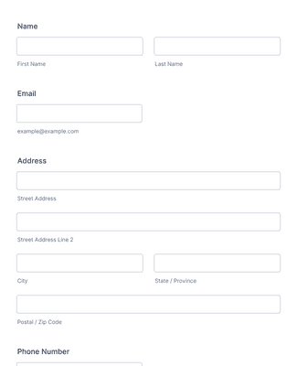

(Muhammad Arif)

Basheer Ahmad

Reg: SP21-BSE-093

# **The brief level case:** **(Basheer Ahmad)**

Use Case: Register (logging in and signing up):

The first thing that a user and costumer should do is to register him/herself to the system for this so at the very first stage there will appear a dash board for asking him/her for user id and password to enter the system and gain its desires and to register to the system.

For additional information the user is used to add to the system you need to enter his/her name address for delivery the items and email to have notifications of new items or medicines come to bazaar.

Use Case: Search the medicine:

After logging in to the system so the client, searches for his/her desired medicine along with its details name, company name, mgs, and other additional information so if it is existing to the store or stock then it goes forward.

Use Case: Purchase medicine:

After entering to the system there will be an option available for selling items and purchasing items or medicines by clicking these buttons. So this command able the user to purchase the needed medicines along with additional information. that this app will provide especially for those people that they are in remote areas by online purchasing where ever he/she is online.

Use Case: Order Quantity:

This command able user to display the quantity of the mention medicine that how much is sufficient for him specially for whole seller this command is so necessary to follow this command carefully

Use Case: Add Card:

So we know that our system is online so the card is so needed for online transaction of money so in this section the costumer should have cards to transfer money online when he/she purchasing the product

Therefore, the costumer will have this facility to share his transaction online through any way that he can like debit cards, master cards easy paisa or etc.

# **The full Address:** **(Basheer Ahmad)**

**Basheer Ahmad (SP21-BSE-093)**

#### **Use Case: Register**

Scope: entering and signing up to the system to access all service from web application.

Primary Actors: Costumer, admin.

Stake holder and interest:

Costumer: costumer is the stakeholder and the person who directly affected with the system and this app pave the way for costumer fully to buy the needed medicine of his/her choice and need and as well with the exact quantity and delivery facility by adding the address.

Admin: Admin can full access of his employees that work with the income and as well the available medicine and needed or short medicine and will have control on his database everywhere.

Preconditions: the costumer and admin should enter to the system through sign up and log in.

Success guarantee (or Post conditions): the access and control on stock will be incredible and easy every employee and the owner will have fully access and awareness.

Main success scenario or Basic flow:

* Employee will have their information through accounts that they created.
* The boss and owner (admin) will have clear control on his application through signing in and will have full information about employees and other workers.
* This app will provide full information about each side of the business.
* Admin can have fully access on each part of this app.

Extension or alternative flows:

At any time, sign up cannot be registered:

* Sometime if the user has, their accounts through logging in also can enter or register.
* It these two ways don not work through email also a user can inform the admin for accessing.
* Alternatively, the third way a customer can physically visit the stock.

If system does not recover:

* The user will suspend the operation and the system will show an error message.
* The user starts a new operation and continue to his work.

Special requirements:

* There should be a special dashboard for signing in and register
* The machine should be connected to system

Technology and Data Variations List:

The biometric machine should be connected to the system.

#### **Use Case: Search medicine:**

Scope: to have full information about the items that the customer need can access through search that particular item.

Primary Actors: Costumer, System.

Stake holder and interest:

Costumer: the customer will have fully facility to search his/her desired medicine and this will be very helpful.

System: System will pave fully in charge for the customer.

Preconditions: the costumer and admin should enter to the system through sign up and log in.

Success guarantee (or Post conditions): the way of purchasing online will be incredible and easy every customer will easily order or get their medicine.

Main success scenario or Basic flow:

* The costumer will have notification of new product that come into stock.
* Customer should search those particular items according to their names.
* The customer should say the amount of the items he/she needed.
* Admin can have fully access on each part of this app.

Extension or alternative flows:

At any time by sign up can be purchase and order:

* Sometime if the user has, their accounts through logging in also can enter and can order or purchase.
* It these two ways don not work through email also a user can inform the admin for accessing.
* Alternatively, the third way a customer can physically visit the stock.

If system does not recover:

* The user will suspend the operation and the system will show an error message.
* The user starts a new operation and continue to his work.

Special requirements:

* There should be a special dashboard for purchasing and ordering.
* The machine should be connected to system and responsible.

#### Use Case: Add Card

Scope: customer and admin should have cards and the payment system for transaction money.

Primary Actors: Costumer, admin.

Stake holder and interest:

Costumer: costumer is the stakeholder and should have cards.

Admin: Admin should have the payment system and bank account for transferring the money

Preconditions: the customer ask about the amount and through dashboard that will be provide will select the transaction method and then the system will ask about password and card number after that if card was valid so the system will show a message “transaction done”.

Success guarantee (or Post conditions): After entering the additional information about card so, the system will show the message of success and failure like:

If succeed: “transaction done”.

If failure: “sorry your code and password is incorrect”.

Main success scenario or Basic flow:

* The customer will have their information about transaction through accounts that they created.
* The boss and owner (admin) will have clear control on his application through signing in and will have full information about money transaction.
* This app will provide full information about each side of the business.
* Admin can have fully access on each part of this app.

Extension or alternative flows:

At any time, sign up cannot be registered:

* Sometimes customer can have directly cash money transformation.
* It these two ways don not work through email also a user can inform the admin for
* accessing to the accounts.
* Alternatively, the third way a customer can physically visit the stock.

If system does not recover:

* The user will suspend the operation and the system will show an error message.
* The user starts a new operation and continue to his work.

Special requirements:

* There should be a special dashboard for transaction that holder of entering code and password of the card.
* The machine should be connected to system

Technology and Data Variations List:

The biometric should be connected to the system.

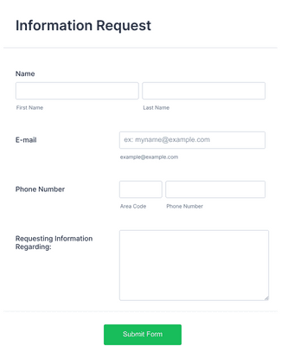

(Basheer Ahmad)

**Dashboard of Medicine Stock**

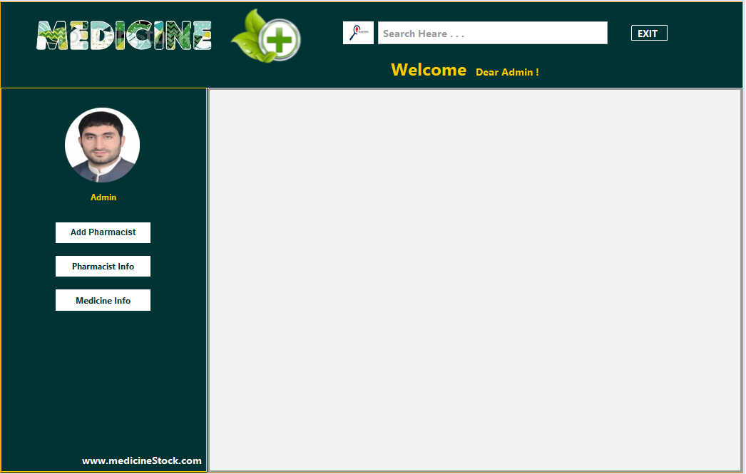

# **CHAPTER 3 SSDs Section.**

## Abdul Qadir SSDs (SP21-BSE-098):

Use Case UC1: Log in

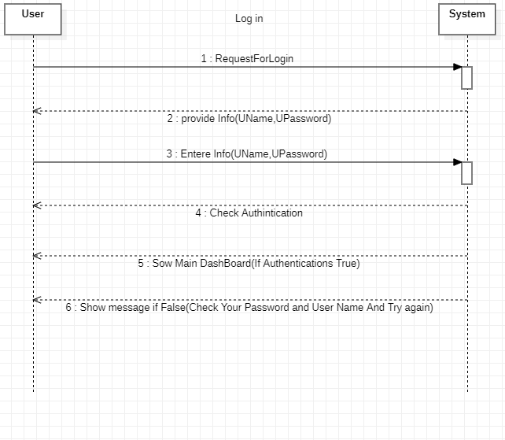

Use Case UC2: Add Employee

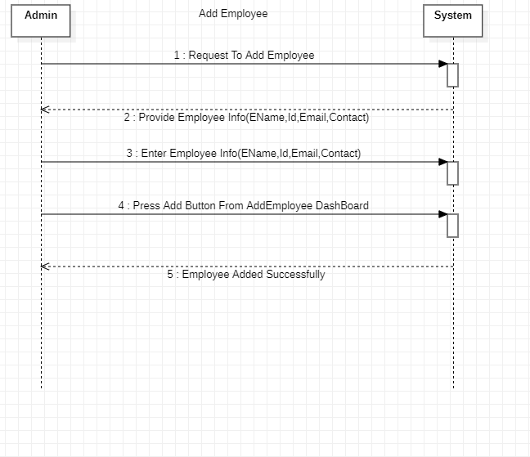

Use Case UC3: Delete employee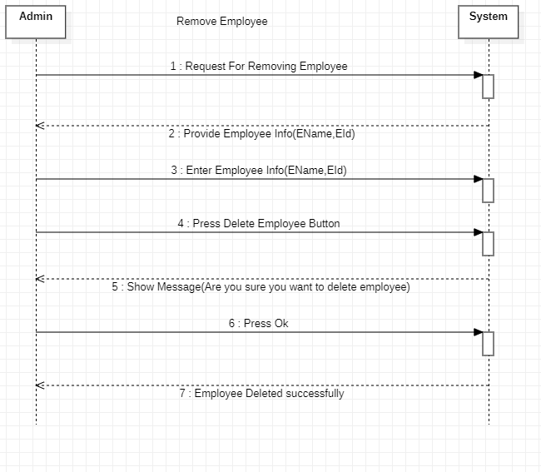

Use Case UC4: Seeing Medicine Information.

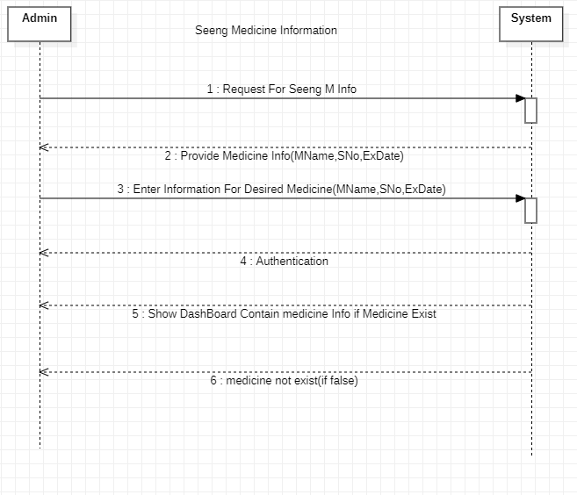

## Muhammad Arif SSDs (SP21-BSE-090):

Use Case UC1: Login



Use Case UC2: Add medicine

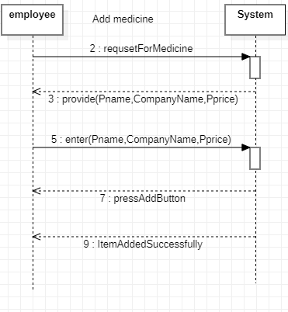

Use Case UC3: Delete Medicine or Update Medicine

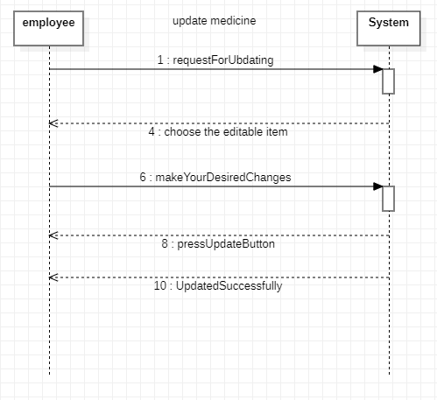

## Basheer Ahmad SSDs (SP21-BSE-093)

Use Case UC1: Login



Use Case UC2: Search for Medicine

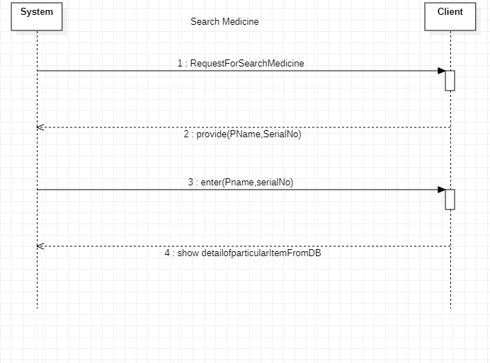

Use Case UC3: Purchasing Medicine

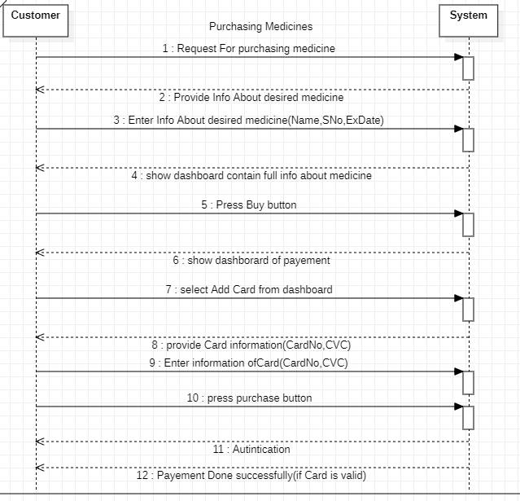

# **CHAPTER 4 Operation Contracts – Sections**

### **Operation Contract of Abdul Qadir (SP21-BSE-098):**

| **Use Case UC1: Login** |
| --- |

**Contract ID**: Log in

**Operation: Employee will login to full access for all functions**

**Cross References:** Use cases: Login

**Pre-conditions:**

Employee will go and will provide login information to login

**Post-conditions:**

The user, employee and customer is now logged in to the system and will have its all necessary information that can make difference for these three

| **Use Case UC2: Add Employee** |
| --- |

**Contract ID**: Add employee

**Operation: Admin can add employees**

**Cross References:** Use cases: Add employee

**Pre-conditions:**

After Login Admin will see dashboard of Adding employee

**Post-conditions:**

Employee added by admin and now admin can access full information about their employees

| **Use Case UC3: Delete Employee** |
| --- |

**Contract ID**: Delete employee

**Operation: Admin can delete employees**

**Cross References:** Use cases: Delete employee

**Pre-conditions:**

After Login Admin will see dashboard of Removing or deleting employees

**Post-conditions:**

Employee deleted by admin and now admin does not have access full information about a particular employee

| **Use Case UC4: Seeing Medicine Information** |
| --- |

**Contract ID**: Seeing medicine status

**Operation: Admin can check all information about a specific product**

**Cross References:** Use cases: Seeing medicine status

**Pre-conditions:**

After Login Admin will see dashboard for accessing information of a product

**Post-conditions:**

Now admin can have full information about expiry date availability of a medicine quantity of medicine and also name serial number and price of a selected medicine by adding some information about that medicine.

### **Operation Contract of Muhammad Arif (SP21-BSE-090):**

| **Use Case UC1: Login** |
| --- |

**Contract ID**: Log in

**Operation: Employee will login to full access for all functions**

**Cross References:** Use cases: Login

**Pre-conditions:**

Employee will go and will provide login information to login

**Post-conditions:**

The user, employee and customer is now logged in to the system and will have its all necessary information that can make difference for these three

| **Use Case UC2: Add Medicine** |
| --- |

**Contract ID**: Add medicine

**Operation:** employee will Add a new medicine.

**Cross References:** Use cases: Add medicine

**Pre-conditions:**

Employee will go and open Add employee dashboard

Employee will add additional information about specific medicine

**Post-conditions:**

The medicine added by employee and customer will have full access of purchasing this medicine and medicine will show on dashboard with full its specifications

| **Use Case UC3: Delete Medicine** |
| --- |

**Contract ID**: Delete Medicine

**Operation: Employee will delete an existing medicine from the stock**

**Cross References:** Use cases: Delete Medicine

**Pre-conditions:**

Employee will go and open Delete Employee dashboard

Employee will complete information about medicine to delete

**Post-conditions:**

The medicine deleted by employee and customer will not have any access of purchasing this medicine and medicine will lose access of this medicine on dashboard with full its specifications

| **Use Case UC4: See Orders** |
| --- |

**Contract ID**: See Order

**Operation: employee can see orders to overcome**

**Cross References:** Use cases: See order

**Pre-conditions:**

Employee will go and open see order dashboard

**Post-conditions:**

Employee now can check whether the new orders are available or not if available so then can provide cards system with its payment method and also can manage the order quantity.

### **Operation Contract of Basheer Ahmad (SP21-BSE-093):**

| **Use Case UC1: Login** |
| --- |

**Contract ID**: Log in

**Operation: Employee will login to full access for all functions**

**Cross References:** Use cases: Login

**Pre-conditions:**

Employee will go and will provide login information to login

**Post-conditions:**

The user, employee and customer is now logged in to the system and will have its all necessary information that can make difference for these three

| **Use Case UC2: Search Medicine** |
| --- |

**Contract ID**: Search Medicine

**Operation: Customer can search the medicine they need**

**Cross References:** Use cases: Search Medicine

**Pre-conditions:**

Customer login and provide information of desired medicine to search wither it exists in the stock or not.

**Post-conditions:**

The new dashboard will open for customer and then customer easily will have access to search the medicine they need by entering (MName, SNo, ExDate).

| **Use Case UC3: Purchasing Medicine** |
| --- |

**Contract ID**: purchasing medicine

**Operation: Customer can buy medicines online**

**Cross References:** Use cases: purchasing medicine

**Pre-conditions:**

Customer login and provide information of desired product

**Post-conditions:**

Customer can dashboards of purchasing the method of payment will show to customer and easily will communicate with software.